
Change the “LATEST NEWS” heading to bold font. Also change to dark blue colour. (The sub-headings can remain as they are.)
There should be 5 news headings under “Companies” (not merely 2), same with “Markets”, “Economy”, “Industry”, “Regulatory” and “Guru Watch”

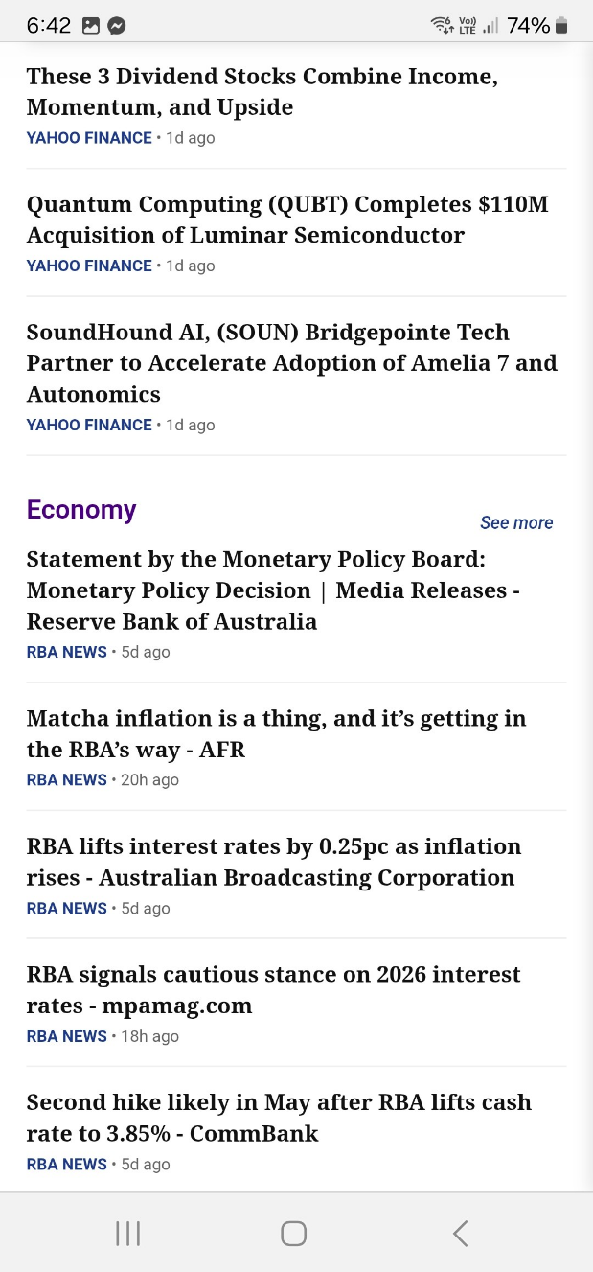
These articles look way too old. They should not be included here or captured by the scraper. The articles should be no more than 48 hours (2 days) old.


Remove the entire “Commodities” section (ie. the heading and its 3 news heading contents)

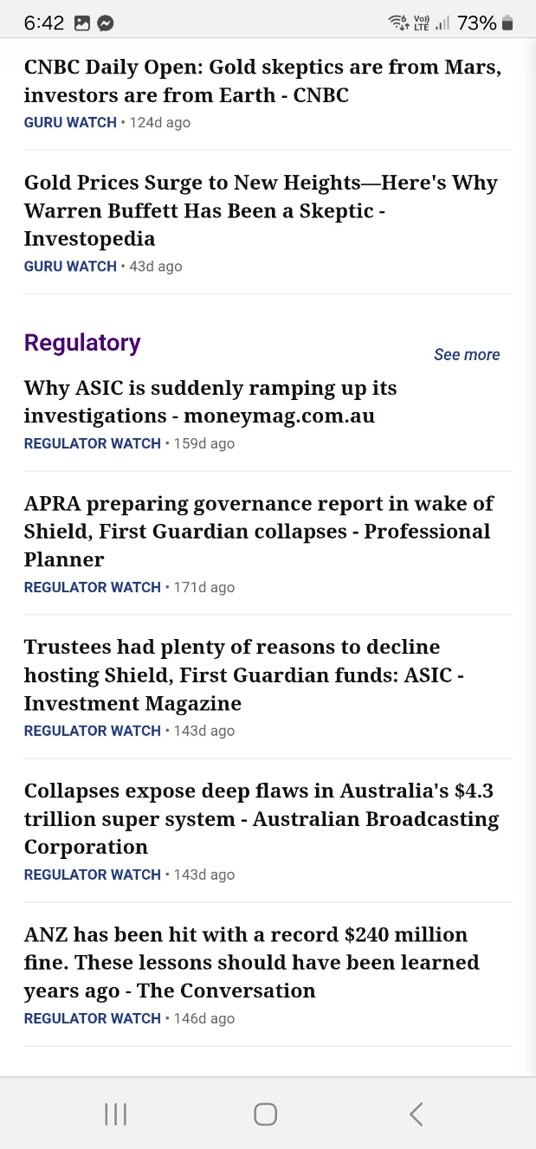
These articles look way too old (eg. “159d ago”. They should not be included here or captured by the scraper. The articles under “Regulatory” should be no more than 7 days old.



These articles look way too old (eg. “159d ago”). They should not be included here or captured by the scraper. The articles should be no more than 48 hours (2 days) old.

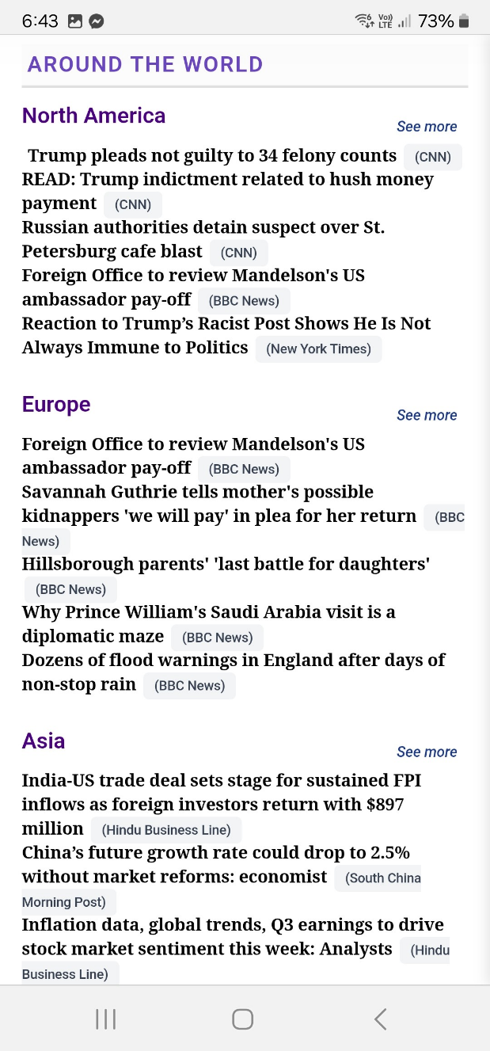
There should be space between each news headline under “AROUND THE WORLD”. The line spacing between each news headline should be the same as under “LATEST NEWS”.

Also the date (ie. how many hours or days ago) should be shown.
Change the “AROUND THE WORLD” heading to bold font. Also change to dark blue colour. (The sub-headings can remain as they are.)
The articles under “North America”, “Europe”, “Asia” and “Elsewhere” look way too old. They should not be included here or captured by the scraper. The articles should be no more than 48 hours (2 days) old.

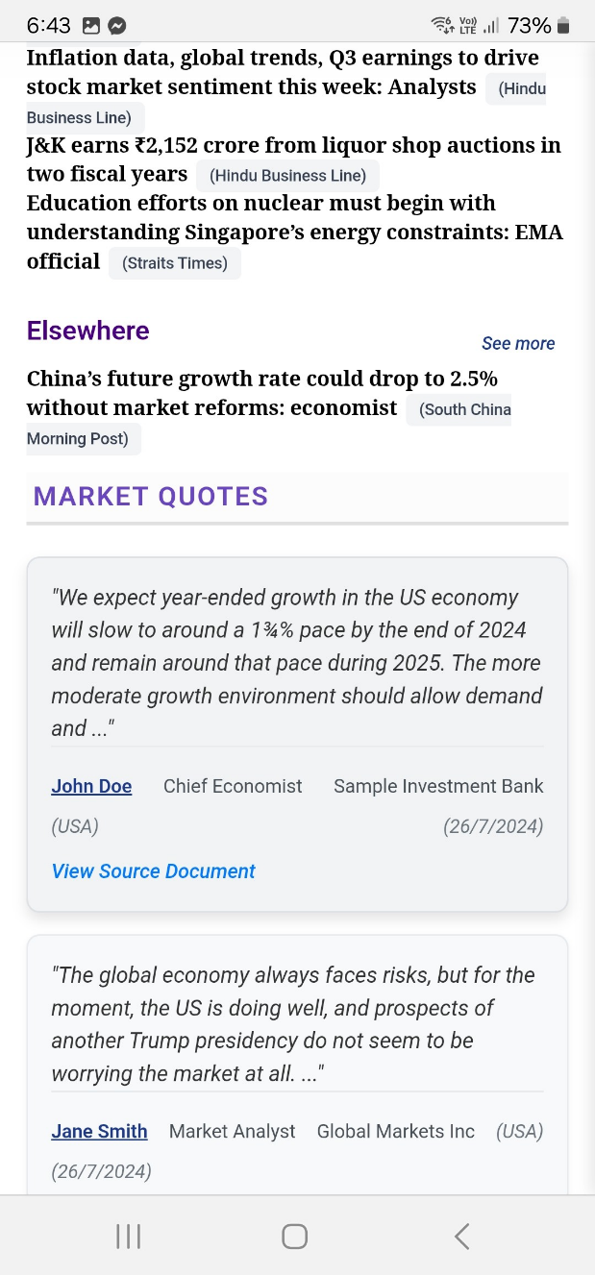
Change the “MARKET QUOTES” heading to bold font. Also change to dark blue colour. (The sub-headings can remain as they are.)
The articles under “Elsewhere” look way too old. They should not be included here or captured by the scraper. The articles should be no more than 48 hours (2 days) old.

Also there should be 5 x news articles (not merely 1).

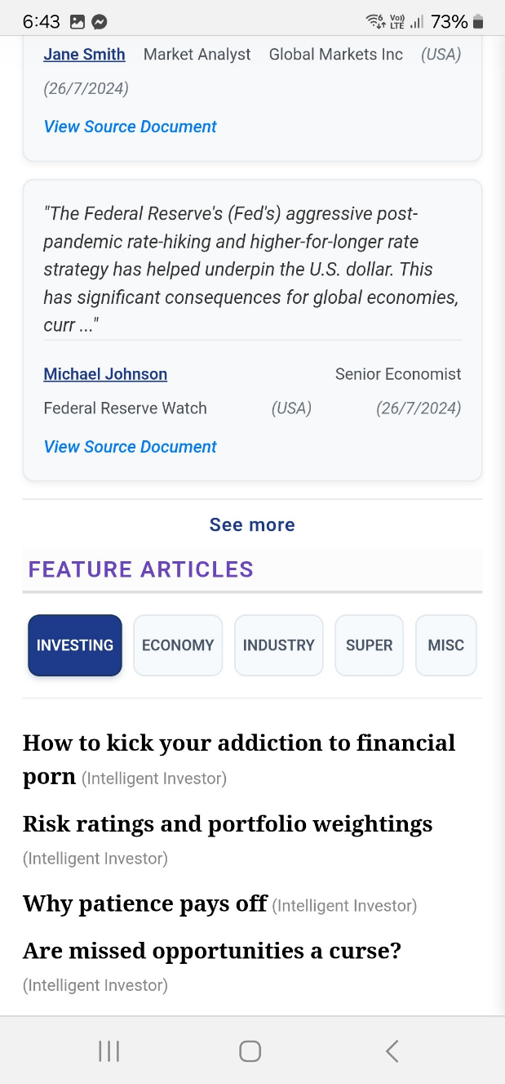
There should be 10 article headings (not 6)
Change the “FEATURE ARTICLES” heading to bold font. Also change to dark blue colour. (The sub-headings can remain as they are.)
The font size of these article headings should be the same as those in the news articles above (ie. slightly smaller).

Display 10 lines of text (instead of merely 6 lines) under each tab of the Home Page.
No 4 is indented too much and does not align with the others
Delete the space before each comma.
The text gets too close to the right-hand margin.

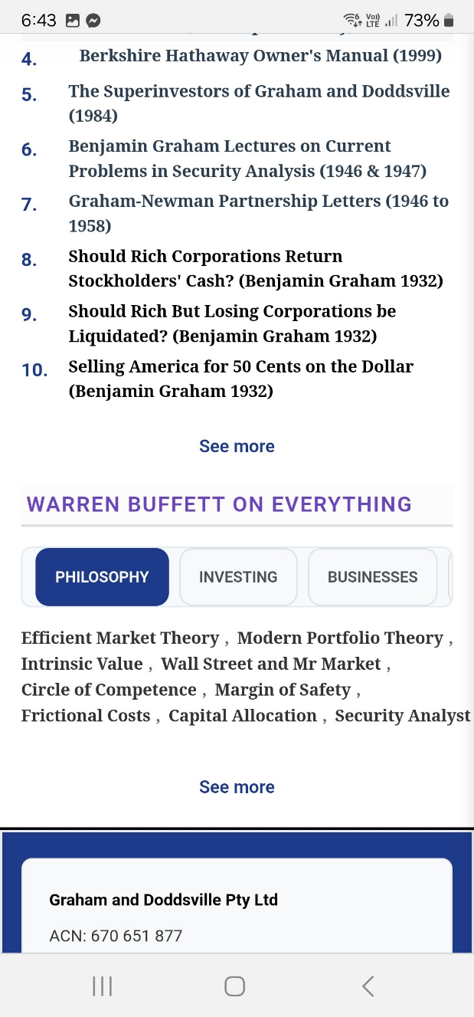
The text gets too close to the right-hand margin.
Display 10 lines of text (instead of merely 4 lines) under each tab of the Home Page. Make sure each term is individually clickable.
Delete the space before each comma.

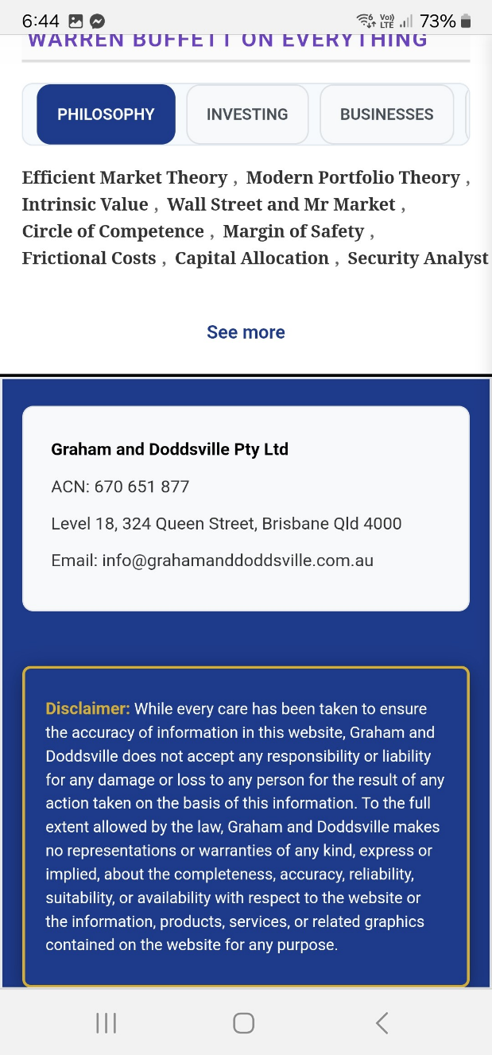
Delete the line spaces between lines 2 and 3

